Assignment 7.1

Submitted By: Ashish Saxena

1. Histogram for all variables in a dataset mtcars. Write a program to create histograms for all columns.

codes

library(purrr)

library(tidyr)

library(ggplot2)

data(mtcars)

mtcars %>%

keep(is.numeric) %>%

gather() %>%

ggplot(aes(value)) +

facet_wrap(~ key, scales = "free") +

geom_histogram()

2. Check the probability distribution of all variables in mtcars

x=data(mtcars)

mtcars

y= dnorm(x, mean=0.0246914, sd=1)

summary(y)

png(file = "dnorm.png")

plot(y)

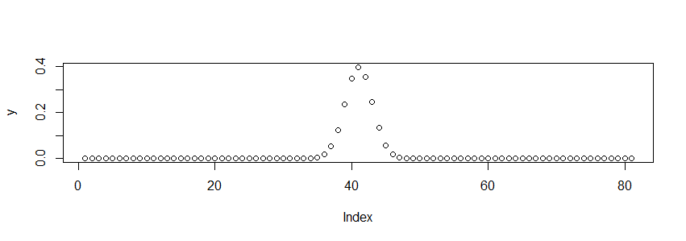

3. Write a program to create boxplot for all variables.

boxplot(mtcars)

